Lecture 11.
Transportation Logistics
A large part of many logistics systems involved the management of a fleet
of vehicles used to serve warehouses, retailers, and/or customers.
In order to control the costs of operating the fleet, a dispatcher must continuously make decisions on how much to load an each vehicle and where to send it. These types of problems fall under the general class of Vehicle Routing Problem (VRP).

Problem Statement
The basic Vehicle Routing Problem is the single-depot Capacitated Vehicle
Routing Problem (CVRP). It can be described as follows:
- A set of customers has to be served by a fleet of identical vehicles of limited capacity.
- Unlimited fleet of vehicles is initially located at a given depot.
- Each route begins at the depot, visits a subset of customers and returns to the depot without violating the capacity constraint.
- The objective is to find a set of routes for the vehicles of minimal total length.

Vehicle Routing Problem
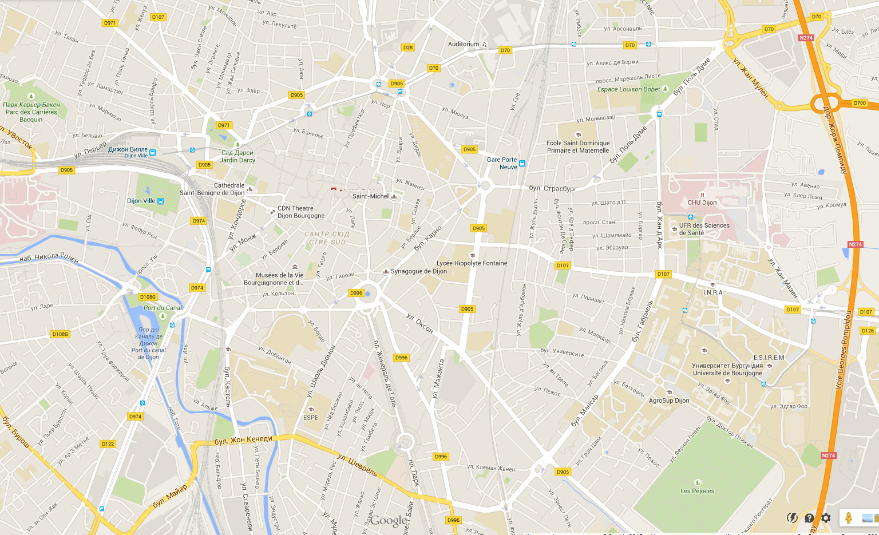
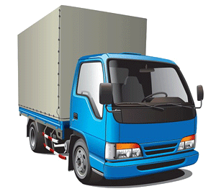
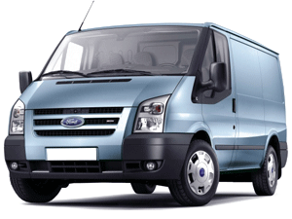

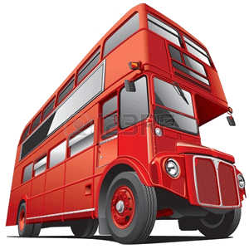

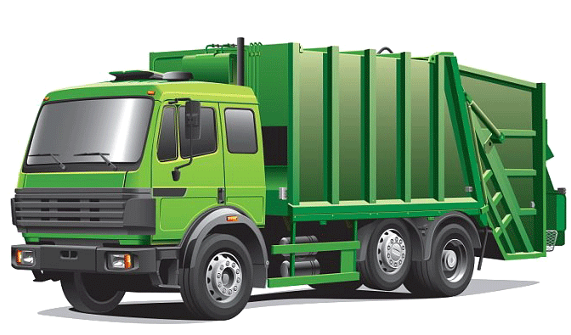

The CVRP
Given
$J=\{0,1,…,n\}$ is the set of customers and $j=0$ is the depot;
$c_{ij}≥0$ is the distance between $i$ and $j$;
$q_{i}≥0$ is the demand of customer $i;$
$Q≥0$ is the capacity of vehicle.

Find a set of routes for the vehicles of minimal total length.
Mathematical Model
Boolean variables:
$x_{ijk}=1$ iff vehicle $k$ visits customer $j$immediately after customer $i;$
$y_{ik}=1$ iff customer $i$ is visited by vehicle $k;$
$$\min{\sum_{i∈V}{\sum_{j∈V}{\sum_{k∈K}{c_{ij}x_{ijk}}}}}$$
$$\sum_{k∈K}{y_{ik}=\left\{\begin{aligned}1, i=1,…,n \\ m, i=0 \end{aligned} ;\right.}$$
$$\sum_{i∈V}{q_{i}}y_{ik}≤Q, k=1,…, m;$$
$$\sum_{j∈V}{x_{ijk}=\sum_{j∈V}{x_{jik}=y_{ik}, i∈J, k=1,…,m;}}$$
$$\sum_{i,j∈S}{x_{ijk}≤\left|S\right|-1, for all S⊆J∖\{0\}};$$
$$x_{ijk}, y_{ik}∈\left\{0,1\right\}.$$
Variants of the Model
- Subtour elimination constraints:
$$\sum_{i∈S}{\sum_{j∈\overline{S}}{x_{ijk}≥1, S⊆J∖\{0\}, 2≤\left|S\right|≤n-1}}, k=1,…,m;$$
$$u_{ik}-u_{jk}+nx_{ijk}≤n-1, i,j∈J∖\{0\}, k=1,…,m.$$
- Heterogeneous fleet;
- Salary of drivers;
- Minimize the number of extra vehicle hired;
- Minimize the number of customers not served in the present period;
- Time windows for serving customers;
- $q_{i}>Q:$ split demand for the CVRP.
A well-solved case of the CVRP
Let us assume that $Q_{k}=Q, k∈K$ and
$$\sum_{i∈S}{q_{i}>Q for each S⊂J∖\{0\}, |S|≥3.}$$
Moreover, the number of customers is even, $c_{ij}$ is symmetric matrix and satisfies the triangle inequality: $c_{ij}+c_{jk}≥c_{ik}, i,j,k∈J.$
In such a case the CVRP can be solved in polynomial time by reduction to the minimum cost matching problem.
How to do that?
Dynamic Programming
Let $f(k,T)$ be the minimal cost of serving all customers in $T⊆J∖\{0\}$ using only the first $k$ vehicles;
$v(T)$ be the minimum cost of a solution to the TSP defined by the depot and the customers in $T;$
$$q\left(T\right)=\sum_{i∈T}{q_{i}}.$$
Dynamic programming recursion:
$k=1:$ $f\left(1,T\right)=v\left(T\right);$
$k≥2: f\left(k,T\right)=\min_{s⊂T}{\{f\left(k-1, T-S\right)+v(S)\}}$
for all$T⊆J∖\{0\}$ such that $q\left(J\right)-\left(m-k\right)Q≤q\left(T\right)≤kQ;$
$q\left(T\right)-\left(k-1\right)Q≤q\left(S\right)≤Q.$

Moreover, we must check only subsets $S$ which satisfy the constraint
$$\frac{1}{m-k} q\left( J∖T\right)≤q\left(S\right)≤\frac{1}{k}q\left(T\right).$$
Informally, the load on route $k$ is greater than the average load on the remaining $m-n$ routes, and less than the average load on the first $k-1$ routes.
Running time is $O(.)$?
Space requirement is $O(.)$?

Hometask. Design DP-algorithm for the Traveling Salesman Problem.
Set Covering Reformulation
Let all optimal single routes for one vehicle be indexed $r=1,…, \overline{r}.$ Let the index set of customers in route $r$ be $M_{r}$ and the cost of the route (optimal TSP for $M_{r}$) be $d_{r}$. We will use $N_{i}=\left\{r \right|i∈M_{r}\}$as the set of all routes which include customer $i∈J.$
Variables: $y_{r}=\left\{\begin{aligned}1, if route r is in the optimal solution \\ 0 otherwise. \end{aligned}\right.$
$$\min{\sum_{r=1}^{\overline{r}}{d_{r}y_{r}}}$$
$$s.t. \sum_{r∈N_{i}}{y_{r}=1, i∈J∖\{0\}; }$$
$$\sum_{r=1}^{\overline{r}}{y_{r}}≤m.$$
Hometask. Consider an instance of the CVRP with 6 customer, two identical vehicles with capacity $Q=6$ and symmetric distance matrix $c_{ij}$:
 | 0 | 1 | 2 | 3 | 4 | 5 | 6
0 | –
1 | 28 | –
2 | 21 | 47 | –
3 | 14 | 36 | 26 | –
4 | 17 | 25 | 37 | 15 | –
5 | 18 | 20 | 30 | 31 | 29 | –
6 | 22 | 35 | 20 | 34 | 39 | 16 | –
The customer demands are $\left(q_{1},…, q_{6}\right)=\left(2,3,1,1,2,1\right).$ Generate all feasible routes to this problem. Write down the Set Covering formulation. Solve this model to optimality by inspection.
Heterogeneous Fixed Sleet CVP
$f_{k}≥0$ is the fixed cost for using vehicle $k$;
$c_{ij}^{k}≥0$ is the traveling cost for vehicle $k$ on the road from $i$ to $j;$
$m_{K}>0$ is the number of vehicles of type $k∈K.$

Variables:
$x_{ijk}=1$ iff vehicle $k$ visits customer $j$ immediately after customer $i$;
$y_{ij}≥0$ is the load of a vehicle during it travel from $i$ to $j$.
HFFCVRP
$$\min\left(\sum_{k∈K}{f_{k}\sum_{j∈J\backslash \{0\}}{x_{0jk}}+\sum_{k∈K}{\sum_{j∈J}{c_{ij}^{k}x_{ijk}}}}\right)$$
$$\sum_{k∈K}{\sum_{i∈J}{x_{ijk}=1, j∈J∖\{0\};}}$$ | $$y_{0j}≤\sum_{k∈K}{Q_{k}x_{0jk}, j∈J∖\{0\};}$$
$$\sum_{i∈J}{x_{ijk}=\sum_{i∈J}{x_{jik}, j∈J, k∈K;}}$$ | $$y_{ij}≤\sum_{k∈K}{\left(Q_{k}-q_{i}\right)x_{ijk}, }$$  $$i∈J∖\{0\}, j∈J, i≠j;$$
$$\sum_{j∈J\{0\}}{x_{0jk}}≤m_{k}, k∈K;$$ | $y_{ij}≥0, x_{ijk}∈\{0,1\}$.
$$\sum_{i∈J}{y_{ij}}-\sum_{i∈V}{y_{ji}=q_{j}, j∈J∖\{0\};}$$ | $y_{ij}≥0, x_{ijk}∈\{0,1\}$.
Subproblem for Given Sequence of Customers
Assume that we know a sequence of visiting the customers by the vehicles $π=\left(π_{1}, π_{2}, …, π_{n}\right).$ If the heterogeneous fleet of vehicles is unlimited, this subproblem of the CVRP can be solved by DP algorithm.

Hometask. Design mathematical model and DP-algorithm for this case.

