Знания-Онтологии-Теории (ЗОНТ-09)

Effect of power system stabilizers and automatic voltage regulator gain on synchronizing and damping torques

Али З.М¹,Маликов А.И.²
^{1,2}Казанский государственный технический университет им. А.Н. Туполева ,Россия, Казань, ул. К.Маркса, 10, кафедра Автоматики и управления КГТУ
Elhalwany10@yahoo.com¹

Abstract: this paper deals with an analysis of the phenomena of stability of synchronous machines under small perturbations by examining the case of a single machine connected to a large system through external impedance, and studies the effect of conventional stabilizers and automatic voltage regulator gain (K_{A}) on electrical torques components at different loading conditions.

Key words : power system stability, automatic voltage regulator, power system stabilizer , and synchronizing and damping torques.

1 Introduction
The phenomenon of stability of synchronous machine has received a great deal of attention in the past and will receive increasing attention in the future . As economies in the system design are achieved with larger unit sizes and higher per unit reactance generating and transmission equipment designs, more emphasis and reliance is being placed on the controls to provide the required and the reliance is being placed on controls to provide the required compensating effects with which to offset the reductions in stability margins inherent from these trends in the equipment design ^{[1]}. The analysis of SMIB ^{[2]} gives physical insight into the problem of low frequency oscillations. These low frequency oscillations are classified into local mode, inter area mode and tensional mode of oscillations. The SMIB system is predominant in local mode low frequency oscillations. These oscillations may sustain and grow to cause system separation if no adequate damping is available. In recent years, modern control theory have been applied to power system stabilizer (PSS) design problems. These include optimal control, adaptive control, variable structure control, and intelligent control. conventional controllers such as a lead-lag compensator, proportional plus integral controllers (PI), proportional plus derivative controllers (PD), and proportional plus integral and derivative controllers (PID) are most popular controllers used in control process because of their remarkable effectiveness and simplicity of implementation, these controllers are overwhelmingly used in industrial applications^{[3,4]}. The basic function of a power system stabilizer is to extend stability limits by modulating generator excitation to provide damping to the oscillations of the synchronous machine rotors relative to one another. These oscillations of concern typically occur in the frequency range of approximately 0.2 to 2.5 Hz, and insufficient damping of these oscillations may limit the transmit power. To provide damping, the stabilizer must produce a component of electrical torque (damping torque) on the rotor, which is in phase with speed variations ^{[5,6].}

2 Power system stabilizer structure
In order to improve the dynamic performance of the system, we may use such controller to balance the phase lag, which resulted from the electrical-loop time delay for ever-increasing the damping torque constituent. Fig.1 gives over all block diagrams for stabilizers that used in this paper.
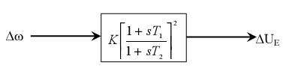  (a) 2 stage lead- lag compensator. | 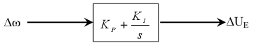  (b) PI Controller.
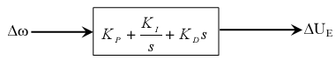  (c) PID Controller. | 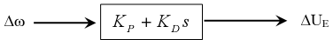  (d) PD Controller.
Fig.(1)
So the transfer function between the control signal ΔU_{E} and Δω can be written as :
$\frac{{ΔU}_{E}}{Δω}=F(s)=\text{PSS}$ (1)
Fig.(3) depicts a general structure for the block diagram after adding (PSS)
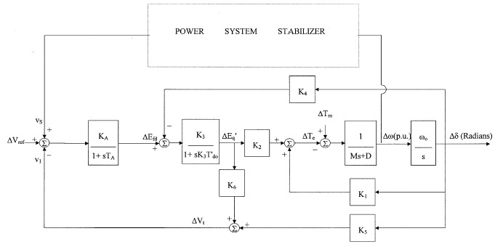
F(s)
Fig.(2) block diagram for closed loop
By using MALTLAB stabilizers parameters are obtained, after that using these parameters to obtain eigenvalues for the system with each stabilizer and under light, normal, and heavy loads, and so study the stability of the system without and with stabilizers under small perturbations. The following table summarizes eigenvalues results at light, normal, and heavy loads respectively at K_{A}=50.
Table (1) eigenvalues at different loads
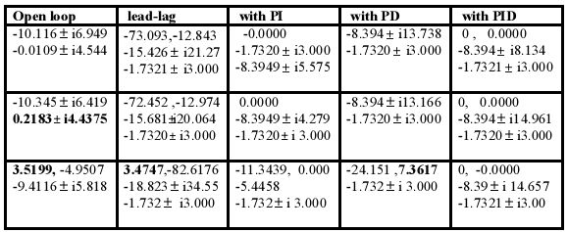
3 Synchronizing and damping torques

The concept used by ^{[6]} of synchronizing and damping torques will be used in this paper .At any given oscillation frequency, breaking torques are developed in phase with machine rotor angle δ (synchronizing torque ) and in phase with machine rotor speed ω (damping torque ). The torque developed by any particular means can be broken down into these components (synchronizing and damping torque) for stability study. Sufficient and necessary condition for the system to be stable is that both synchronizing and damping torques are positive. Positive synchronizing torque assures restoring of the rotor angle of the machine following an arbitrary small displacement of this angle, but positive damping is necessary to damp out any oscillation due to any perturbation. Since the damping torque and synchronizing torque are both important in the power system stability. The contribution of PSS on these torques is studied. In a small signal oscillation the synchronizing torque is in phase with Δδ or –jΔω, and the damping torque is in phase with Δδ or j Δω. Therefore they can be calculated ^{[2]}
${ΔT}_{e}|_{K1}=K_{1}Δδ$ (2)
${ΔT}_{e}|_{{}_{K4}}=\frac{−K_{2}K_{3}K_{4}\left(1+{\text{ST}}_{A}\right)}{K_{3}K_{6}K_{A}+\left(1+{\text{ST}}_{{\text{do}}^{'}}K_{3}\right)\left(1+{\text{ST}}_{A}\right)}Δδ$ (3)
${ΔT}_{e}|_{K5}=\frac{−K_{2}K_{3}K_{5}K_{A}}{K_{3}K_{6}K_{A}+\left(1+{\text{ST}}_{{\text{do}}^{'}}K_{3}\right)\left(1+{\text{ST}}_{A}\right)}Δδ$ (4)
${ΔT}_{e}|_{U_{e}}=\frac{K_{2}K_{3}K_{A}F(S)}{K_{3}K_{6}K_{A}+\left(1+{\text{ST}}_{{\text{do}}^{'}}K_{3}\right)\left(1+{\text{ST}}_{A}\right)}Δω$ (5)
Where eq(5) can be written as following
$${ΔT}_{e}|_{U_{e}}=\frac{K_{2}K_{3}K_{A}F(S)}{K_{3}K_{6}K_{A}+\left(1+{\text{ST}}_{{\text{do}}^{'}}K_{3}\right)\left(1+{\text{ST}}_{A}\right)}\frac{S}{ω_{b}}Δδ$$
So from superposition theory By replacing the operator s by jω in Eqn. (3-5) and separating the real and imaginary parts, then the synchronizing torque coefficient represented by real part and damping torque coefficient represented by imaginary part
ΔT_{e}=${ΔT}_{e}|_{{}_{K4}}$+ ${ΔT}_{e}|_{K1}$+${ΔT}_{e}|_{K5}$+${ΔT}_{e}|_{U_{e}}$
Synchronizing and damping torque coefficient can be used as an indication for the stability of power system under small perturbation by drawing them with loading, where the system is considered stable at the point of loading where both of them are positive , but if one of them is negative so the system is considered unstable. The following figures represent the synchronizing and damping torques with loading without and with power system stabilizers:
(3-a) synchronizing torque with loading for system without PSS | (3-b) Damping torque with loading for system without PSS
(3-C) Synchronizing torque with loading at Q=0.3 p.u. with stabilizers | (3-d) Damping torque with loading at Q=0.3 p.u. with stabilizers
From Figs.(3-a, -b, -c and -d), it is concluded that the synchronizing and damping torques are improved after adding stabilizers for certain stabilizers gains ( K, t₁, K_{P},K_{I,} and K_{d}), and these figures give over all view to predict the response of the power system under small perturbation and at certain reactive power
4 Automatic voltage regulator gain (K_{A})
From previous equations (2,3,4, and 5), it is noticed that the AVR gain or automatic voltage regulator may be has an effect on the stability of the system, so it better to study the effect of changing AVR gain on the synchronizing and damping torques and hence know it's effect on system stability.
Following figures depict the synchronizing and damping torques coefficients for system without stabilizers at different values of AVR gain (K_{A}) for normal, heavy, and light loads.
(4-a) synchronizing torque with K_{A} at normal load | (4-b) Damping torque with K_{A} at normal load
From Figs. ( 4-a, -b), it is concluded that system will be stable if K_{A} < = 25 for system without PSS, and this result matches with eigenvalues results in table (1), where these result taken at K_{A}=50 for all loading conditions.
(4-c) synchronizing torque with K_{A} at heavy load | (4-d) Damping torque with K_{A} at heavy load
From Figs.(4-c, and -d) , it is concluded that the system without PSS will be stable at heavy load if K_{A} <=10, and this also matches with eigenvalues results that was obtained before.
(4-e) synchronizing torque with K_{A} at light load. | (4-f) Damping torque with K_{A} at light load
From Figs.(4-e, and -f) it is concluded that system will be stable without PSS for all values of K_{A}.
5 Conclusions
From table (1) it is clear that system after adding stabilizers model that taken under study be more stable especially at light, normal, and at heavy load. These eigenvalues results are confirmed after obtaining figures which express the effect of stabilizers on synchronizing and damping torques, and this effect clear by obtaining positive damping torques after adding stabilizers, but about the effect of AVR gain (K_{A}), from results in pervious figures, it is concluded that the (K_{A}) hasn't any effect to change the response of the system , in another words, the only controller that control the response of system without PSS under small perturbation is loading.
Data of the system under study
- Synchronous Machine  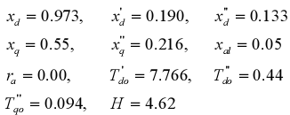 | - Excitation System  - Operating point  -Nominal Load  -Light Load  -Heavy Load
References
[1] Ali.Z.M, and ELsherbiny M.," effect of both mechanical and excitation system on power system and methods of improvement.", M.sc, Egypt, Assuit university,2003.
[2] J.Satheeshkumar. Jegadeesan, et al," A Novel approach for tuning Power System Stabilizer (SMIB system) using Genetic Local Search technique.", Department of Electrical Engineering, Government College of Technology, Coimbatore, INDIA ,2005 .
[3] S.Chen and O.P. Malik, “ Power System Stabilizer Design using ^{μ} Synthesis”, IEEE trans. on Energy Conversion, Vol. 10, N.o 1, March 1995 .
[4] K.J Astrom and T.Hagglund, “Automatic Tunning of PID controllers”, Instrument
society of America, 1998 .
[5] S. E. M. Oliveira, “ Effect of Excitation Systems and of Power System Stabilizers on Synchronous Generators Damping and Synchronizing Torques”, IEE Proc.,Vol. 136, Pt. C, No. 5, September 1989.
[6] F. P. Demello and C. Concordia, “ Concepts of Synchronous Machine Stability as Affected by Excitation System”, IEEE trans, on Power Apparatus and Systems,Vol. 88, No. 4, pp. 316-329, April 1969.

